CS 25-335 | Streamline process for using

AI powered projects to help digital marketers save time in the contact creating process

Project Proposal

Prepared for

Amanda Roberts

The Roberts Group

By

Marcio Tejeda, David Newman, Ethan DuBrueler, and Noah Davis

Under the supervision of

Caroline Budwell

10/11/2024

**Executive Summary**

This project aims to develop an AI platform for digital marketers in the travel industry that aids with content generation and expedites the process of destination travel booking for their clients. The key features include:

* A chatbot that helps travelers select their ideal hotel based on preferences like location, budget, and desired experience.
* AI-generated videos showcasing the users' desired destinations.
* Hotel recommendations based on user input.

Through the automation of these processes, the platform seeks to save marketers time, improve the end-user experience, and provide personalized recommendations based on user preferences. The project is expected to further the use of AI in digital marketing, specifically in the travel industry, while also meeting the sponsor's goal of simplifying content creation and improving user engagement.

**Table of Contents**

Section A. Problem Statement 5

Section B. Engineering Design Requirements 7

B.1 Project Goals (i.e. Client Needs) 7

B.2 Design Objectives 7

B.3 Design Specifications and Constraints 8

B.4 Codes and Standards 9

Section C. Scope of Work 11

C.1 Deliverables 11

C.2 Milestones 12

C.3 Resources 12

Section D. Concept Generation 13

Section E. Concept Evaluation and Selection 14

Section F. Design Methodology 16

F.1 Computational Methods (e.g. FEA or CFD Modeling, example sub-section) 16

F.2 Experimental Methods (example subsection) 16

F.5 Validation Procedure 16

Section G. Results and Design Details 18

G.1 Modeling Results (example subsection) 18

G.2 Experimental Results (example subsection) 18

G.3 Prototyping and Testing Results (example subsection) 18

G.4. Final Design Details/Specifications (example subsection) 18

Section H. Societal Impacts of Design 20

H.1 Public Health, Safety, and Welfare 20

H.2 Societal Impacts 20

H.3 Political/Regulatory Impacts 20

H.4. Economic Impacts 20

H.5 Environmental Impacts 21

H.6 Global Impacts 21

H.7. Ethical Considerations 21

Section I. Cost Analysis 22

Section J. Conclusions and Recommendations 23

Appendix 1: Project Timeline 24

Appendix 2: Team Contract (i.e. Team Organization) 25

Appendix 3: [Insert Appendix Title] 26

References 27

### Section A. Problem Statement

The digital marketing space, particularly within the travel industry, faces a significant challenge in providing personalized, engaging content to potential travelers while efficiently managing the booking process. Travel marketers often face the burden of creating dynamic content, curating personalized recommendations, and streamlining processes–all of which are time-consuming and labor-intensive. In contrast, with increasing consumer demands for personal experiences, digital marketers fall behind when it comes to the volume of content creation. The lack of automation in these areas is reflected in wasted time, inconsistency in user experience, and low conversions. This affects digital marketers, who are under pressure to deliver more quality, personalized content faster, and it affects the end-users who often have fragmented experiences when navigating travel bookings. The main goal of this project is to help streamline these processes through AI-driven solutions that can further enhance the marketing and user experience through the provisioning of rapid tools that efficiently create content and book hotel stays.

The travel industry is one of the most competitive and technology has contributed immensely to influencing the trends in consumer behavior. Recently, it has been seen that travelers are drifting to personalization and immersion into experiences enabled by their desire to have tailor-made vacation plans and distinctive stays. This demand has culminated in work overload for digital marketers because they have to come up with relevant content again and again that appeals to consumers. The sponsor feels the need for an AI-enabled platform to meet these challenges. The travel industry still heavily relies on agents to do most of the heavy lifting when working with clients; travel agents create destination presentations, answer follow-up queries, and guide travelers through the booking process. The absence of AI-powered tools has introduced inefficiencies, reduced conversion rates, and overwhelmed travel agents. In this project, we automate these processes and enhance the marketing-to-booking funnel.

Ultimately, this project bridges the gap between the need for efficiency on the part of digital marketers and the personalized experience expected by the travelers themselves. The project will plug certain long-standing inefficiencies in the travel marketing process by introducing an AI-powered platform capable of integrating chatbots, AI video generation, and direct hotel booking capabilities. The ultimate goal is to make it easier on the travel agency while simultaneously making the travel planning of the end user seamless, enjoyable, and highly personalized. This will, in turn, reinforce overall user satisfaction and differentiate the sponsor from its competitors.

**[add figures, flow chart, visuals, cite at least 5 references, etc.]**

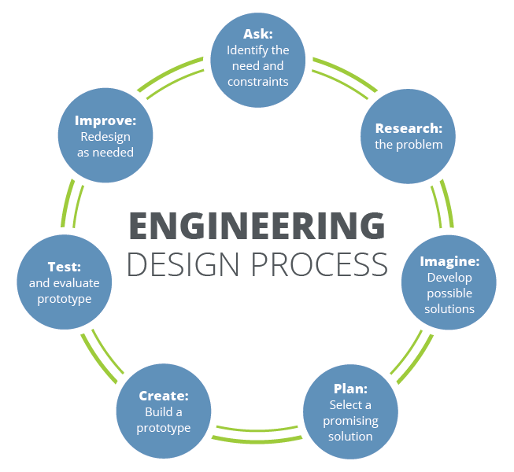

**Figure 1. The iterative nature of the engineering design process [2].**

### Section B. Engineering Design Requirements

#### B.1 Project Goals (i.e. Client Needs)

* To create a platform that enables digital marketers to generate content faster using AI technology.
* To integrate chatbot features that assist users in finding personalized hotel recommendations.
* To implement AI-driven video generation to create visual content more easily.
* To allow users to book specific hotels directly from the website, reducing friction in the booking process.

#### B.2 Design Objectives

* The platform will have a user-friendly chatbot that helps users select hotels based on preferences such as location, budget, and occasion.
* AI video generation will enable marketers to create and customize videos quickly, helping them save time in their content creation processes.
* The website will feature seamless hotel booking functionality, allowing users to complete transactions without being redirected to external pages.

#### B.3 Design Specifications and Constraints

* Chatbot functionality must be integrated with existing travel data and support natural language processing (NLP) for user queries.
* AI video generation should produce customizable, high-quality videos tailored to the marketing needs of various industries.
* Hotel booking capabilities must be secure and fully integrated into the platform, with payment options and booking confirmations handled in-app.
* Hotel recommendations must use an affiliate link from the travel agency.
* Cost considerations include ensuring the platform is scalable and easy to maintain.

#### B.4 Codes and Standards

* ISO/IEC Standard 27001 – ensures the confidentiality, integrity, and availability of information in our system
* PCI DSS Code – ensures secure handling of credit card information during hotel bookings
* NIST SP Standard 800-53 – provides guidelines for selecting and specifying security controls for information systems
* ISO Standard 20488 – principles and requirements for the collection, moderation, and publication of customer reviews
* W3C Standard HTML5 – establishes guidelines for structuring and presenting content on the World Wide Web

### 

### Section C. Scope of Work

The project scope defines the boundaries of the project encompassing the key objectives, timeline, milestones and deliverables. It clearly defines the responsibility of the team and the process by which the proposed work will be verified and approved. A clear scope helps to facilitate understanding of the project, reduce ambiguities and risk, and manage expectations. In addition to stating the responsibilities of the team, it should also explicitly state those tasks which fall *outside* of the team’s responsibilities. *Explicit bounds* on the project timeline, available funds, and promised deliverables should be clearly stated. These boundaries help to avoid *scope creep*, or changes to the scope of the project without any control. This section also defines the project approach, the development methodology used in developing the solution, such as waterfall or agile (shall be chosen in concert with the faculty advisor and/or project sponsor). Good communication with the project sponsor and faculty advisor is the most effective way to stay within scope and make sure all objectives and deliverables are met on time and on budget.

Project Scope:

The main focus of the project is to develop an AI-based content creation service, and showcase its use in a new fully functioning travel agent website for our sponsor.

The website will incorporate all the main features and functions of the sponsor’s current website, including the “destinations”, “about”, “connect”, “weddings”, and “honeymoons” pages, but also utilize our AI service to improve its user engagement and retention through high quality AI-generated showcase videos, and a new travel-oriented virtual assistant. The added blog page on the website will be used to share interesting stories about different travel destinations, with steps integrated to book hotels based on those destinations. We’ll also be including direct links to the hotels throughout the site, so that the user can quickly set up arrangements instead of having to work through additional resort/destination sites. Finally, all these new changes and features, including the virtual assistant, will contain destinations options that match the sponsor’s affiliate destinations options, helping support our sponsor.

Overall, this new website will leverage new AI image, video, voice, and conversational text generation capabilities to enhance the user experience and better identify and support their travel needs.

Project Approach:

Our team plans to develop the final product using an iterative approach. With this approach, we start by working with the sponsor to define specific features and functions to implement for the website, and from there, create design docs/plans for implementation, develop demos and prototypes, showcase those demos and prototypes, gain feedback from the sponsor, and continue to develop our demos into fully functioning software.

As needed, we’ll update whatever features we need improvements, define KPIs for each of those features, test our implementations against those KPIs, and adjust our implementations to meet our designated thresholds for them.

Throughout this project, as we meet regularly with our sponsor and advisor we’ll work to share progress, refine our designs, and ultimately complete a new AI powered travel website to launch for our sponsor.

#### C.1 Deliverables

The project deliverables are those things that the project team is responsible for providing to the project sponsor. They are the things that are to be produced or provided as a result of the engineering design process. Some deliverables might include a specific number of alternative designs, required analyses to prove the design meets specifications, detailed machine drawings, functional diagrams or schematics, required computer code, flow charts, user manuals, desktop models, and functioning prototypes. A design “proof of concept” is not specific and should be more clearly defined. Academic deliverables include the team contract, project proposal, preliminary design report, fall poster and presentation, final design report, and Capstone EXPO poster and presentation. Provide a bulleted list of all agreed upon project deliverables.

* Functional Prototypes and Demonstrations
* Completed Website
* Project Proposal
* Design Report
* Fall Poster
* Final Design Report
* Capstone EXPO Poster

In order to mitigate risks associated with the completion and delivery of the project deliverables, provide an outline of the most potentially disruptive, foreseeable obstacles. Some important issues to discuss with the design team, sponsor, and faculty advisor include the following:

* What deliverables require access to campus? Which/how many students regularly access campus and are physically available to complete tasks?
  + No deliverables will need to be physically presented at campus. Everything can be worked on virtually via Discord and submitted virtually via Canvas.
* What work can be done remotely? What resources might be needed in order to ensure that remote work can be completed effectively (e.g. software licenses, shared drives/folders, etc.)?
  + The Github repository to share documentation and prototypes has been created and provided already. Discord is used for project communication and collaboration. The only paid software licenses we need are the OpenAI API key. The Sandals API and other APIs incorporated are free.
* What deliverables require ordering from third-party vendors? Will any components potentially required extended lead times? What can the team do in order to mitigate potential supply chain disruptions?
  + We’ll likely use API calls in order to produce AI-generated content for the site, and to provide links to directly access hotel booking webpages. In order to mitigate disruptions there, we’ll implement caching and updating at regular intervals, to ensure that even if APIs are down, the website will still be able to serve the content it needs to

#### C.2 Milestones

| Timeline | Projections |
| --- | --- |
| → 10/10 | Website scaffolding complete with fine-tuned chatbot interface, video generation scaffolding coded and working |
| 10/11 - 10/24 | Chatbot becomes more conversational rather than giving recommendations after just 1 sentence, images in video generation are far more relevant and professional |
| 10/25 - 11/07 | High-quality videos are pre generated for all destinations the site offers and placed in the “Destinations” tab, high-quality promotion of the her promo is generated in the “Blogs” tab |
| 11/08 - 11/21 | The ability to book hotels is integrated into the website and the video generation api is integrated directly into the website. |
| 11/22 - 12/17 | Ensure the website is functioning together and has all necessary features working on a single website. |

#### C.3 Resources

As we complete our project, we will need to use available resources to cultivate the desired features for our user interface. One of which is OpenAI’s API key for a fine-tuned version of GPT-4o Mini, trained on all allotted travel destinations, which is more than 60% cheaper than GPT 3.5 Turbo and is competitive in user preference with GPT 4[1]. Since this model is so cheap, $5 is all that is necessary to access the API and it costs $0.90 per fine-tuning run after the free period ends on October 31st, but nothing until then. Additionally, we will build the foundation in such a way that any better, cheaper model that comes out can be easily swapped in. We will also incorporate the affiliate link to The Roberts Group (<https://www.sandals.com/?referral=138577>) and showcase a promotion for her code to help integrate our user interface into the way the company is currently run. We will also require a website domain name so that we can make our site accessible to the public.

### Appendix 1: Project Timeline

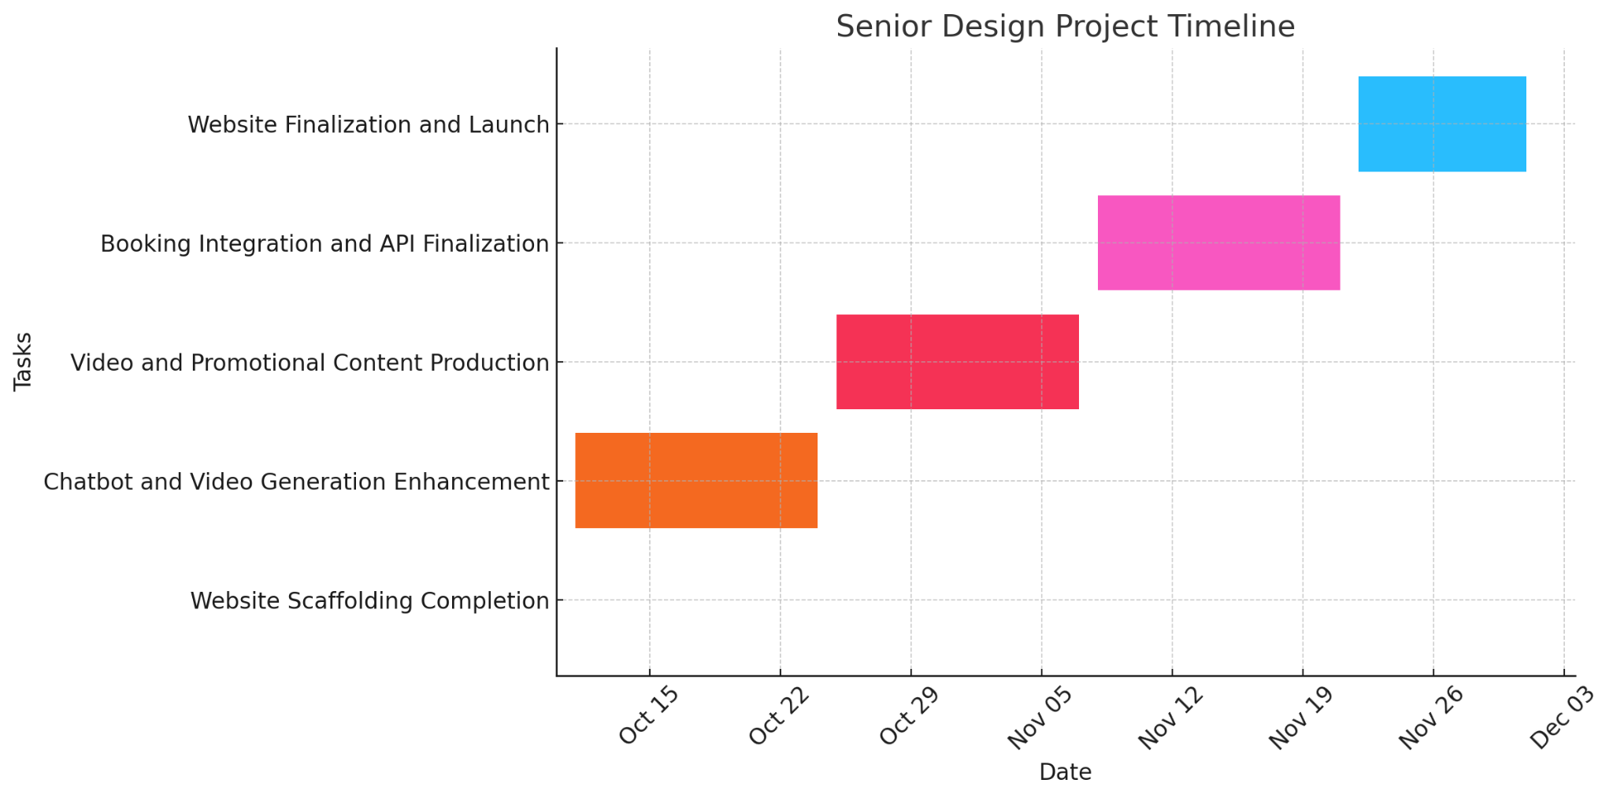

### Appendix 2: Team Contract

# Step 1: Get to Know One Another. Gather Basic Information.

| ***Team Member Name*** | ***Strengths each member bring to the group*** | ***Other Info*** | ***Contact Info*** |
| --- | --- | --- | --- |
| *Noah Davis* | *Organization, leadership* | *Strongest Languages:*  *C++, Java, VBA* | *davisne2@vcu.edu* |
| *Marcio Tejeda* | *Web dev, accounting* | *Strongest Languages:*  *Java, JavaScript, Python.* | *tejedamr@vcu.edu* |
| *David Newman* | *Previous project experience, web dev, sql* | *Strongest Languages:  Python, SQL, ReactJS* | *newmand3@vcu.edu* |
| *Ethan DuBrueler* | *Knowledge of AI tools + YouTube AI automation videos* | *Strongest Languages:*  *Java, Python, C++, SQL* | *dubruelerem@vcu.edu* |

| ***Other Stakeholders*** | ***Notes*** | ***Contact Info*** |
| --- | --- | --- |
| *Faculty Advisor - Caroline Budwell* | *We will meet on Zoom on Thursdays at 10 am.* | *ccbudwell@vcu.edu* |
| *Sponsor - Amanda Roberts* | *We will meet once a month on Thursday at 6 pm.* | *Amanda@thevacationchic.com* |

# Step 2: Team Culture. Clarify the Group’s Purpose and Culture Goals.

| ***Culture Goals*** | ***Actions*** | ***Warning Signs*** |
| --- | --- | --- |
| *Open Communication* | * *Actively notify the group on the status of project, responsibilities, or bug/error issues.* * *Weekly Status Updates on discord from each one.* | * *Miss weekly status update, receive notification to notify group of status.* |
| *Innovation and Creativity* | * *Allocate time for creative thinking* * *Encourage calculated risk-taking and view failures as learning opportunities* | * *Over-reliance on traditional solutions* * *Instant dismissal of out of the box ideas* |
| *Teamwork and Collaboration* | * *Use collaborative software like Canvas, Discord, and Zoom* * *Use collaborative decision making when deciding which path to take* | * *Resistance to helping colleagues or sharing workloads* * *Frequent miscommunication or information hoarding* |

# Step 3: Time Commitments, Meeting Structure, and Communication

| ***Meeting Participants*** | ***Frequency***  ***Dates and Times / Locations*** | ***Meeting Goals***  ***Responsible Party*** |
| --- | --- | --- |
| *Students Only* | *As needed on our Discord voice channel* | *Update group on day-to-day challenges and accomplishments while brainstorming forecasts for where and how the project will reach its next stage.*  *Noah will record these so any meaningful segments can be added to the weekly progress reports and for future reference.* |
| *Students Only* | *Thursdays following the Zoom call with Advisor* | *Actively work on the project as a group and assist any members who are in a roadblock. Ethan will take any meaningful pictures/screenshots as documentation for the week.* |
| *Students + Faculty advisor* | *Every Thursday at 10 am on Zoom* | *Update faculty advisor on project status and find answers to our questions. David will record these meetings for future reference* |
| *Project Sponsor* | *Thursdays from 6 to 7 once a month. If the sponsor is available, we’ll figure out Zoom or in person details. If not, then we’ll update the sponsor via email.* | *Update project sponsor of all advances since previous meeting and make sure we are on the right track (Marcus will scribe and create meeting agenda; Ethan will present preliminary prototype)* |

# Step 4: Determine Individual Roles and Responsibilities

| ***Team Member*** | ***Role(s)*** | ***Responsibilities*** |
| --- | --- | --- |
| *Noah Davis* | *Systems Engineer* | *Develop robust systems for quality assurance and maintain high standards of quality throughout all processes.* |
| *David Newman* | *Systems Engineer* | *Analyze Client initial design specification and lead establishment of product specifications; monitor, coordinate and manage integration of subsystems in the prototype; develop and recommend system architecture to manage product interfaces.* |
| *Marcio Tejeda* | *Project Manager* | *Keep track of goals, delegate tasks, communicate with stakeholders and team members.* |
| *Ethan DuBrueler* | *Manufacturing Engineer* | *Oversee and help plan the layout and blueprint for the project and work to ensure everything runs smoothly in the time window.* |

# 

# Step 5: Agree to the above team contract

*Team Member: Marcio Tejeda Signature: Marcio Tejeda*

*Team Member: David Newman Signature: David Newman*

*Team Member: Ethan DuBrueler Signature: Ethan DuBrueler*

*Team Member: Noah Davis Signature: Noah Davis*

### References

Provide a numbered list of all references in order of appearance using APA citation format. The reference page should begin on a new page as shown here.

[1] *GPT-4O Mini: Advancing Cost-Efficient Intelligence*, OpenAI, 18 July 2024, openai.com/index/gpt-4o-mini-advancing-cost-efficient-intelligence.